**Human Growth and Development**

[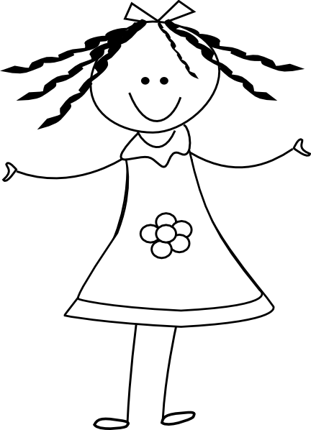](http://www.google.com/url?sa=i&rct=j&q=girl+clipart&source=images&cd=&cad=rja&uact=8&ved=0CAcQjRw&url=http://quotes.lol-rofl.com/happy-girl-clipart/&ei=kCK0VPaZG-3nsATkl4CQBg&bvm=bv.83339334,d.cWc&psig=AFQjCNFPOIeoMvznwlUQ-CPwrLf7456ptg&ust=1421177852480874)

Girls Packet

4th Grade

**Central Bucks School District**

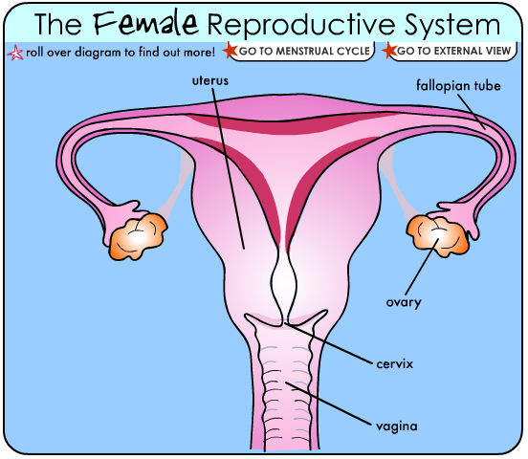

Keeping clean.

As you grow up, you will begin to sweat more- especially under your arms- and your sweat can smell bad.

To keep your body clean:

[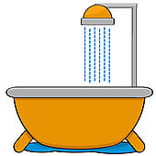](http://www.google.com/url?sa=i&rct=j&q=&esrc=s&frm=1&source=images&cd=&cad=rja&uact=8&ved=0CAcQjRw&url=http://www.fotosearch.com/illustration/shower-head.html&ei=kra2VOGBF5PfgwSV8oLgDg&bvm=bv.83640239,d.eXY&psig=AFQjCNHXw4uanos_wXjDKeWkGiStJILKLA&ust=1421346630022103)

Take a bath or shower every day- especially after you exercise. Make sure to use soap and rinse completely.

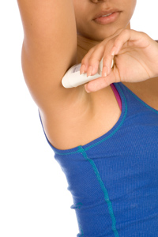

1. [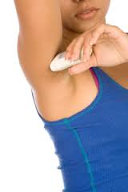](http://www.google.com/url?sa=i&rct=j&q=&esrc=s&frm=1&source=images&cd=&cad=rja&uact=8&ved=0CAcQjRw&url=http://health.howstuffworks.com/skin-care/underarm-care/tips/men-women-deodorants.htm&ei=aLe2VNuAEoa5ggT5uYPICA&bvm=bv.83640239,d.eXY&psig=AFQjCNFGLjbz58bnMZOl_lyWgQs-xD2AXg&ust=1421347044188800)

After every bath or shower, use an antiperspirant or deodorant under your arms. Antiperspirants and deodorants come in sprays and solids. Ask an adult to show you how to use yours.

[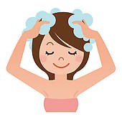](http://www.google.com/url?sa=i&rct=j&q=&esrc=s&frm=1&source=images&cd=&cad=rja&uact=8&ved=0CAcQjRw&url=http://www.fotosearch.com/illustration/shampoo.html&ei=vri2VKmCC5GGNsvmgvgK&bvm=bv.83640239,d.eXY&psig=AFQjCNH-_KE26NReAGdeBHvDEw7NZqQz0w&ust=1421347387931388)

Shampoo your hair often (some girls shampoo every day). Always be sure to rinse out all the shampoo.

[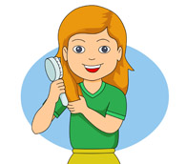](http://www.google.com/url?sa=i&rct=j&q=&esrc=s&frm=1&source=images&cd=&cad=rja&uact=8&ved=0CAcQjRw&url=http://classroomclipart.com/clipart/page-9/Clipart/Health.htm&ei=Lbm2VNO-F4OYgwSs8YPwDQ&bvm=bv.83640239,d.eXY&psig=AFQjCNH4EiEG2g1sug2Hy6vCA4vJ-AQbrA&ust=1421347491817563)

Brush your hair every day to keep it neat.

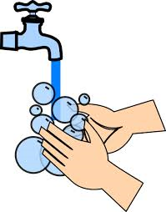

Wash your hands often with soap and water to help stop germs from spreading. Always wash your hands before you eat, after you use the bathroom and after you cough or sneeze.

1. [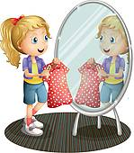](http://www.google.com/url?sa=i&rct=j&q=&esrc=s&frm=1&source=images&cd=&cad=rja&uact=8&ved=0CAcQjRw&url=http://www.fotosearch.com/illustration/broken-mirror.html&ei=Yrq2VPqaCIykgwT8gIHQDA&bvm=bv.83640239,d.eXY&psig=AFQjCNGxFeNbXoa1llz2UM8fVJelutOAdQ&ust=1421347782292312)[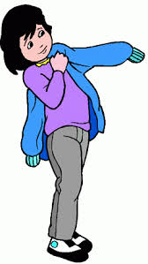](http://www.google.com/url?sa=i&rct=j&q=&esrc=s&frm=1&source=images&cd=&cad=rja&uact=8&ved=0CAcQjRw&url=http://pixgood.com/putting-on-a-jacket-clipart.html&ei=Frq2VLjcBcyfggT614KwAw&bvm=bv.83640239,d.eXY&psig=AFQjCNG9HjxkYNbnbI8D3kF4Ngtx9on-8w&ust=1421347721008129)

Put on clean clothes, including clean socks and underwear, every day.

How to use a pad. It’s easy

Always change your pad in private, in the bathroom.

If you need help, ask an adult you trust.

[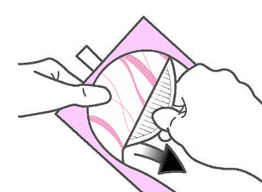](http://www.google.com/url?sa=i&rct=j&q=&esrc=s&frm=1&source=images&cd=&cad=rja&uact=8&ved=0CAcQjRw&url=http://always.ie/NewEnviveUK/en_UK/quickly_open.php?from%3Dliner&ei=sLu2VLO1No3hggTUxoCwCA&bvm=bv.83640239,d.eXY&psig=AFQjCNFoaFLW_K6pDDSKU44aFsNZPIdTGg&ust=1421348138465622)

Pull off the paper from the back of the pad to uncover the sticky strip.

[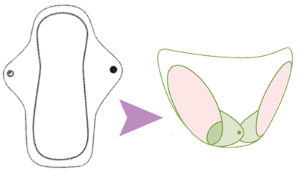](http://www.google.com/url?sa=i&rct=j&q=&esrc=s&frm=1&source=images&cd=&cad=rja&uact=8&ved=0CAcQjRw&url=http://www.kellyscloset.com/Pink-Daisy-Organic-Cotton-Feminine-Pads-3-Pack_p_4544.html&ei=sr22VIq8BMqpgwT_4YCQBA&bvm=bv.83640239,d.eXY&psig=AFQjCNHWh9XEK2BaQTEr1W4LmxPTiiPw_g&ust=1421348653580141)

Attach the sticky part to the middle of your underwear.

[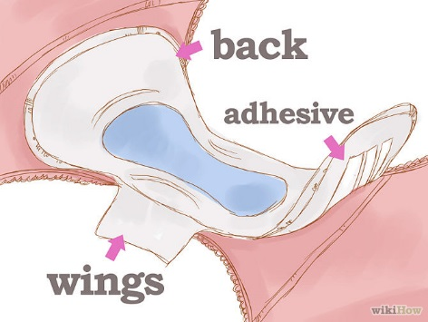](http://www.google.com/url?sa=i&rct=j&q=&esrc=s&frm=1&source=images&cd=&cad=rja&uact=8&ved=0CAcQjRw&url=http://www.wikihow.com/Survive-Your-First-Period&ei=XLy2VOiVGsK4ggTcwoCIAQ&bvm=bv.83640239,d.eXY&psig=AFQjCNHbbi7E7Uuo4pk7v--xlR4ws2cmMg&ust=1421348245766186)

If your pad has "wings;' pull off the paper from the wings and wrap the wings around the sides of your underwear.

Change your pad every 4-6 hours to stay feeling clean and fresh.

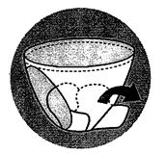How to get rid of a used pad.

When you change your pad, just pull it off your underwear (pull the wings off first).

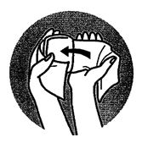

Fold up the used pad. Wrap the pad in tissue or toilet paper.

[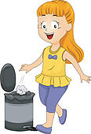](http://www.google.com/url?sa=i&rct=j&q=put++in+trash+can+clipart&source=images&cd=&cad=rja&uact=8&ved=0CAcQjRw&url=http://www.fotosearch.com/illustration/trash-bin.html&ei=HsK2VJahNa-1sQT1o4LIDw&bvm=bv.83640239,d.cWc&psig=AFQjCNFgn8UIgjAvNJLgzHwgJFWp-qlO1A&ust=1421349740711327)

Put the pad in the trash.

[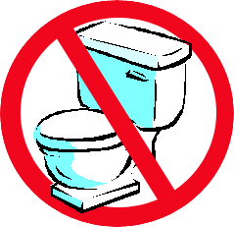](http://www.google.com/url?sa=i&rct=j&q=do+not+flush&source=images&cd=&cad=rja&uact=8&ved=0CAcQjRw&url=http://www.bloomberg.com/news/2014-09-08/flush-defying-wipes-bedevil-cities-as-sewers-surrender.html&ei=ZMK2VP_OPJaLsQTh-4GIDg&bvm=bv.83640239,d.cWc&psig=AFQjCNH6eoJ-vAwsbS-73PP5K2eO9uFXfw&ust=1421349842999688)DON'T flush a pad down the toilet. It will clog the toilet.

 Wash your hands with soap.

**Grade 4**

**Glossary of Terms**

**Females**

**Adolescence:** The period of life during which a person grows from child to adult from about ages 10 to 21.

**Bladder:** A small, elastic sac in the body that stores urine.

**Cervix:** The lower opening of the uterus where it connects to the vagina.

**Egg:** The reproductive cell produced by a female.

**Endometrium:** The mucous membrane lining of the uterus.

**Estrogen:** The hormone which promotes the development of puberty in a girl.

**Fallopian Tube:** Either of a pair of tubes that transport the egg cells from the ovary to the uterus.

**Genitals:** External sex organs.

**Hormone:** A substance that controls activity of another part of the body.

**Menstruation:** Monthly discharge of blood and fluid from the uterus in females who have reached puberty and are not pregnant.

**Menstrual Flow:** The fluid made of tissue and blood that leaves the uterus through the vagina during menstruation.

**Ovary:** One of the female sex organs that produce egg cells and hormones.

**Ovulation:** The ripening and release of an egg cell from the ovary.

**Ovum:** One egg cell.

**Period:** A common term for menstruation.

**Pituitary:** Small oval gland at the base of the brain; puts out hormones that influence growth and most of the basic functions of the body.

**Puberty:** Beginning of physical maturation in a boy or girl.

**Sanitary Napkin:** Absorbent pad worn outside the body for protection during menstruation.

**Urethra:** The canal that carries urine from the body.

**Uterus:** Pear-shaped female reproductive organ in which the fetus grows and develops; also called the womb.

**Vagina:** Passageway leading from the uterus to the outside of the body in a female.

Name Teacher Date

**Knowing Yourself Worksheet**

1. Because of the rapid growth that takes place during adolescence, good nutrition is needed. Which of the following meals would be the most healthful?

a. Hamburger, vegetables, bread, fruit, milk

b. Pizza, french fried potatoes, pickle, Coke

c. Spaghetti, soda, chocolate cake, coffee

2. Why is it necessary for adolescents to bathe more frequently than you did as a child?

3. How might the use of deodorants help an adolescent?

4. As an adolescent you must have plenty of sleep because your body is growing and changing rapidly.

a. How many hours do you usually sleep each night? _

b. How many hours of sleep do you need each night in order to wake up alert the next day? _

5. List three activities which can help you develop your body and strengthen your muscles.

b. _

6. How can the physical changes which occur during adolescence affect the way you feel about yourself?

7. How does the fact that girls develop earlier than boys affect the way the two behave toward each other?